Tree Diagrams
Below are labelled and named tree diagrams for the given TBS and zybook requirements.

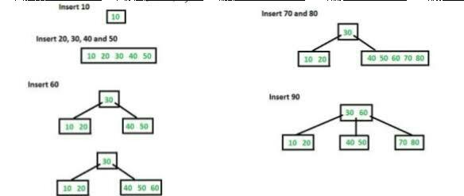
.
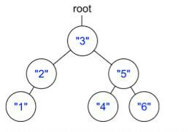
The second tree below shows a comparison between BST and zybook output
